|  |  |
| --- | --- |
| Team Member Full Name | NetID |
|  |  |
|  |  |
|  |  |
|  |  |

# Chosen Technology Stack

|  |  |
| --- | --- |
| Python + Django | Python + TkInter |

# Features Implemented for Phase 1

* Feature A
* Feature B
* Feature C
* …

# Persistent Storage Design

***Describe here (in details) how your project is persisting data. Describe its format and schema. Include diagrams (all figures should have captions).***

***For example: “We are using SQLite database to persist our data. Our database includes the tables shown in Figure 1. It contains N tables. The Question table…”***

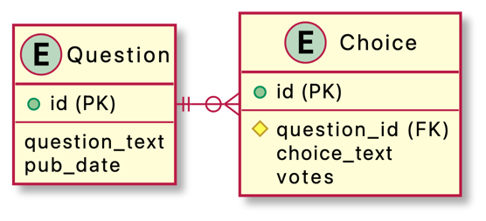

Figure database schema

# Demonstration of the Features Implemented for Phase 1

***It should have at least one screenshot per feature. This should include not only the screenshots but also an explanation for them! Make sure the screenshots have good resolution (i.e., they can be readable when printed).***

## Feature A

Figure N shows a screenshot for …. Lorem ipsum dolor sit amet, consectetur adipiscing elit, sed do eiusmod tempor incididunt ut labore et dolore magna aliqua. Ut enim ad minim veniam, quis nostrud exercitation ullamco laboris nisi ut aliquip ex ea commodo consequat. Duis aute irure dolor in reprehenderit in voluptate velit esse cillum dolore eu fugiat nulla pariatur. Excepteur sint occaecat cupidatat non proident, sunt in culpa qui officia deserunt mollit anim id est laborum.

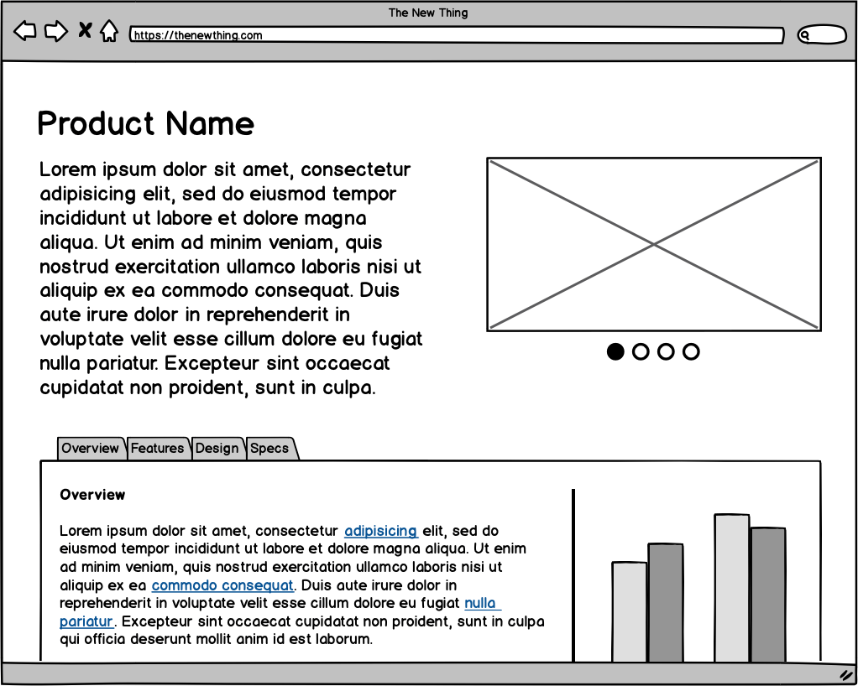

Figure Screenshot for feature A showing ...

## Feature B

Figure N shows a screenshot for …. Lorem ipsum dolor sit amet, consectetur adipiscing elit, sed do eiusmod tempor incididunt ut labore et dolore magna aliqua. Ut enim ad minim veniam, quis nostrud exercitation ullamco laboris nisi ut aliquip ex ea commodo consequat. Duis aute irure dolor in reprehenderit in voluptate velit esse cillum dolore eu fugiat nulla pariatur. Excepteur sint occaecat cupidatat non proident, sunt in culpa qui officia deserunt mollit anim id est laborum.

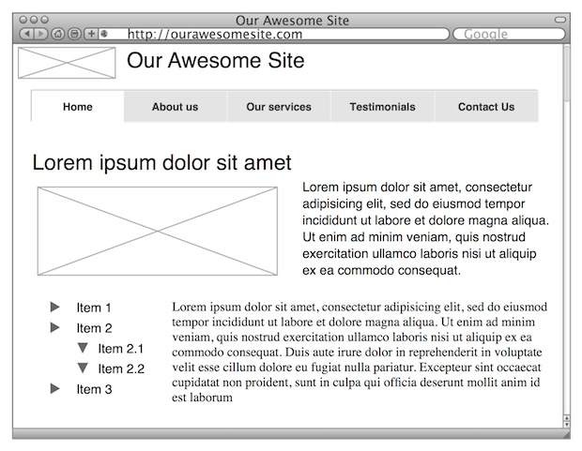

Figure screenshot for feature B

## Feature C

Figure N shows a screenshot for …. Lorem ipsum dolor sit amet, consectetur adipiscing elit, sed do eiusmod tempor incididunt ut labore et dolore magna aliqua. Ut enim ad minim veniam, quis nostrud exercitation ullamco laboris nisi ut aliquip ex ea commodo consequat. Duis aute irure dolor in reprehenderit in voluptate velit esse cillum dolore eu fugiat nulla pariatur. Excepteur sint occaecat cupidatat non proident, sunt in culpa qui officia deserunt mollit anim id est laborum.

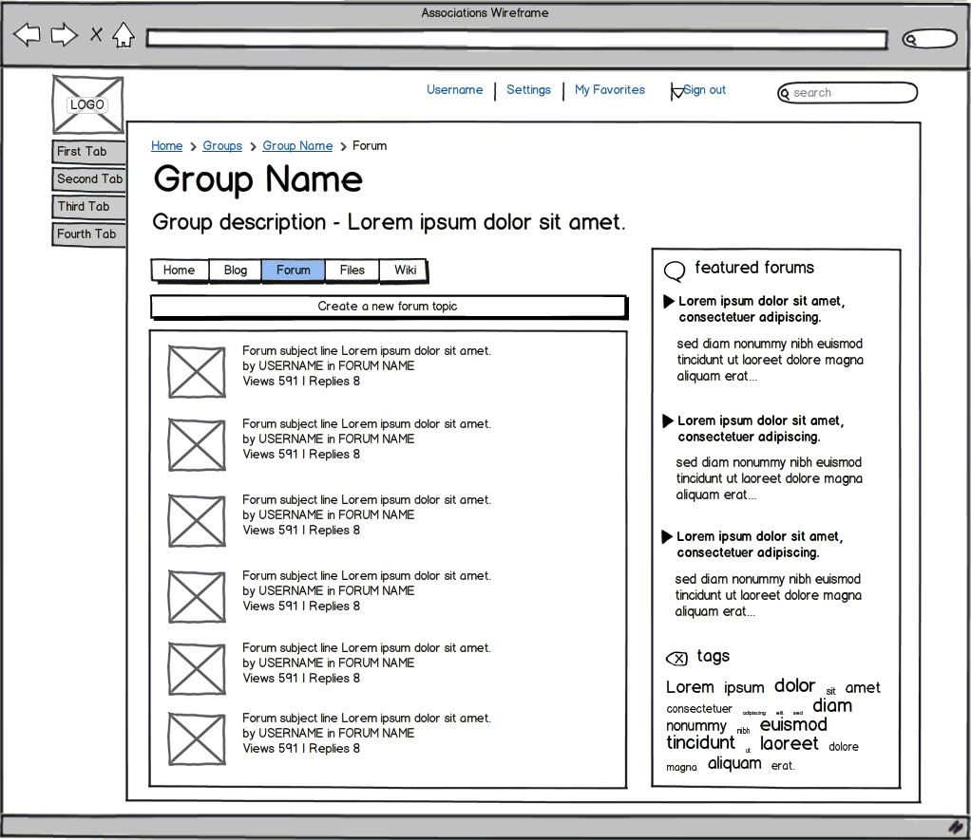

Figure screenshot for feature C